Bill Payment Consumer Guide



Member FDIC

Landing Page 1

Messages 2

Support Phone Number 2

Attention Required 2

Add a Payee 2

Display and Payee List 2

All 2

Shortcut 2

Last 30 Days 3

eBills 3

Company 3

Individuals 3

Inactive 3

Hidden 3

Search your payees 3

Pending 4

History 4

Add a Payee 4

Popular Payees 4

Adding Payees 5

Pay a Company 5

Pay an Individual 6

Activation Process 8

Pay a Bank or Credit Union 12

Manage Payees 13

Hide Payee 15

Show Hidden Payees 16

Scheduling Payments 16

One Time Payments 16

Recurring Payments 18

View Pending Transactions 18

View History 20

Calendar 21

My Account 22

Pay From Accounts 22

Add Accounts 22

View Accounts 23

Personal information 24

Bill Pay Alerts 25

View Alerts 25

View Reminders 26

Payee Categories 26

Add Categories 26

View Categories 27

FAQ 27

Help Tab 27

## Landing Page

At a glance users can view and manage their bill pay account.



**The bill pay site is screen reader compatible.**

 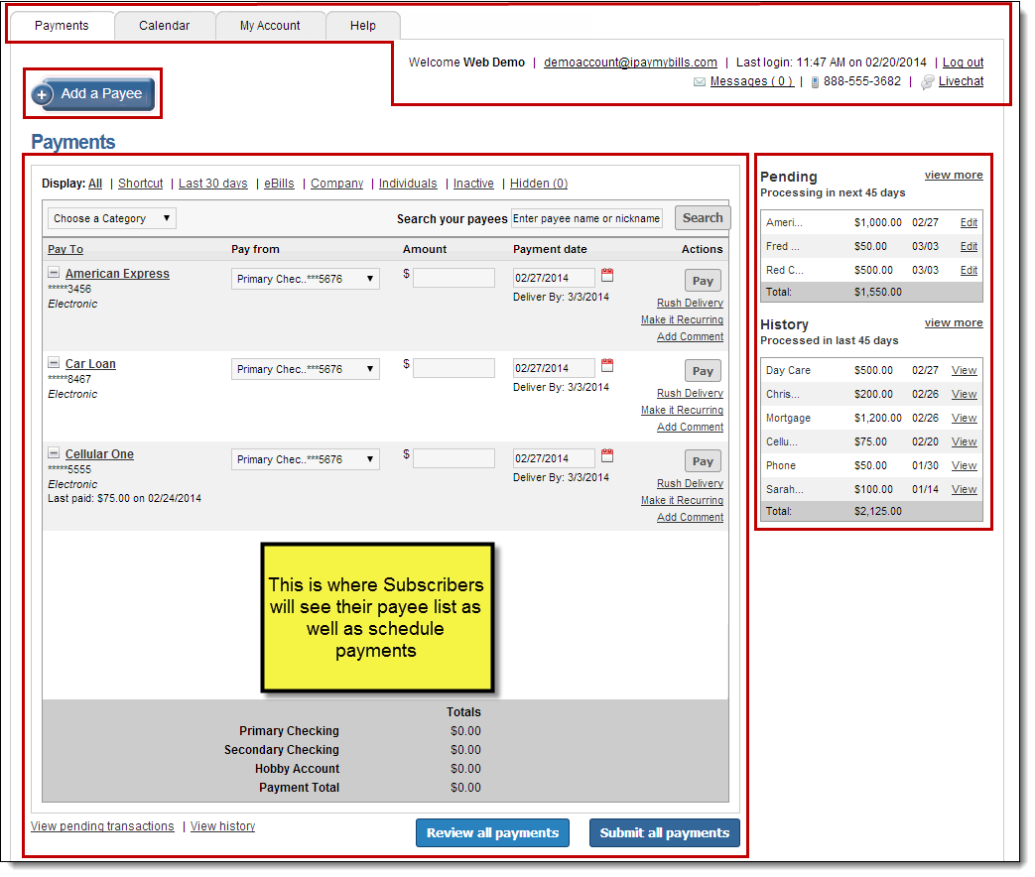

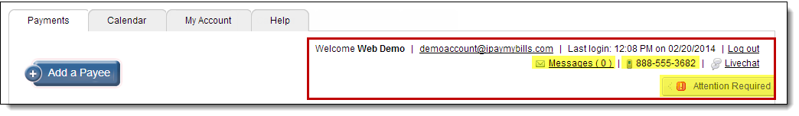

### Messages

This secure message center allows users to receive communications regarding Bill Pay.

* Secure messages will remain in the message center for 180 days or until they are deleted.

### Support Phone Number

The number to contact support.

### Attention Required

The alert section displays actions that must be taken by users. This section will only appear when attention is required on the bill pay site.

### Add a Payee

Allows users to add payees into the bill pay site.

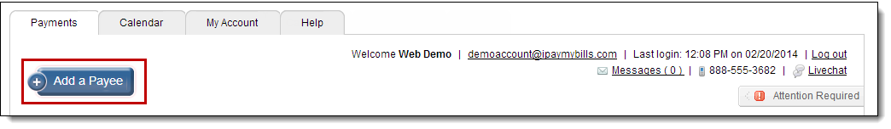

### Display and Payee List

Displays all active payees in the Subscriber’s site and allows them to schedule payments.

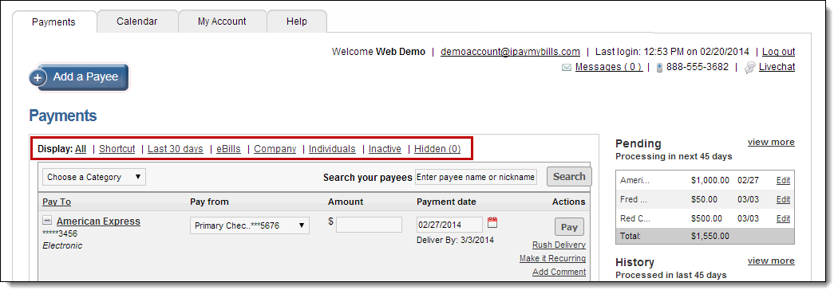

#### All

Displays all of the Subscriber’s payees.

#### Shortcut

Shortcut to pay payments that populate based on previous bill payment history.

#### Last 30 Days

Displays all payees that have a payment paid out within the last 30 days.

#### eBills

Displays all payees that are enabled for eBill.

#### Company

Displays all payees that were added as a company.

#### Individuals

Displays all payees that were added as an individual.

#### Inactive

Displays payees that were added in the last 28 days where payments were not scheduled or payees that have not been paid in the last 181 days.

#### Hidden

Displays payees selected by Subscribers using the ‘Hide’ icon.

#### Search your payees

Allows Subscribers to search for their payees by the payees’ full or partial name or nickname.

### C:\Users\satcher\AppData\Local\Temp\SNAGHTML527ec601.PNGPending

Displays all transactions that are in a scheduled status to process within the next 45 days.

* Option to “**Edit**”
  + Transactions can be “**Stopped**” once “**Edit**” is selected.

### History

Displays all transactions that have processed or paid within the last 45 days.

* Option to “**View**”

## Add a Payee

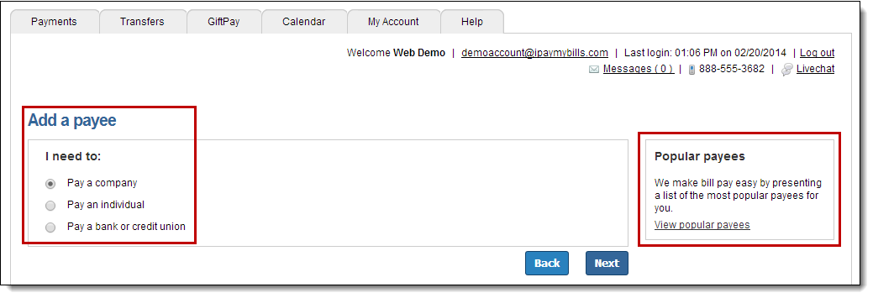

### Popular Payees

* This will display between one and ten of the most popular payees within the user’s zip code.
* These are only available for new users within their first 90 days of enrollment.
* Users will only be required to enter in their account number to add in the payee.

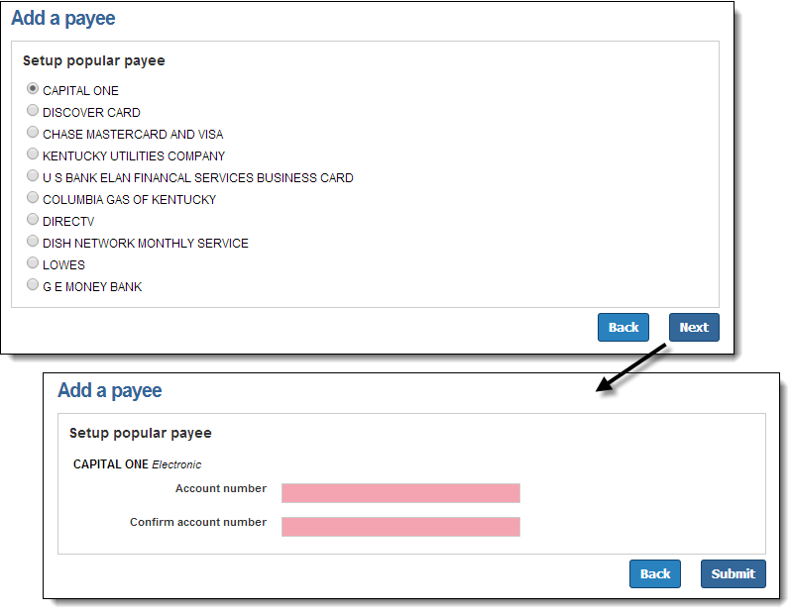

### Adding Payees

#### Pay a Company

When adding a company, users will need to enter the information from their remittance statement.

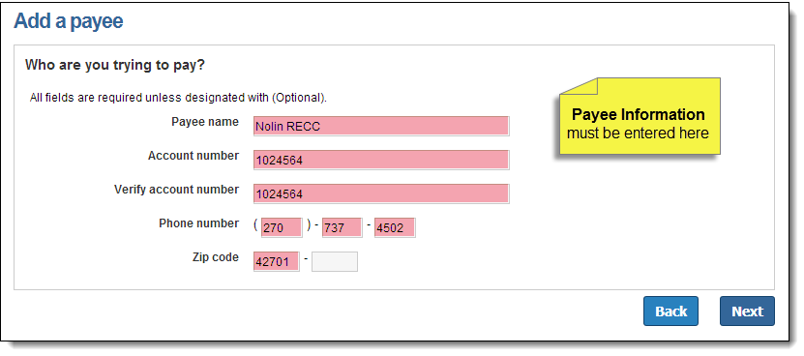

Bill Pay may locate the payee in the system based on the information entered on the previous screen.

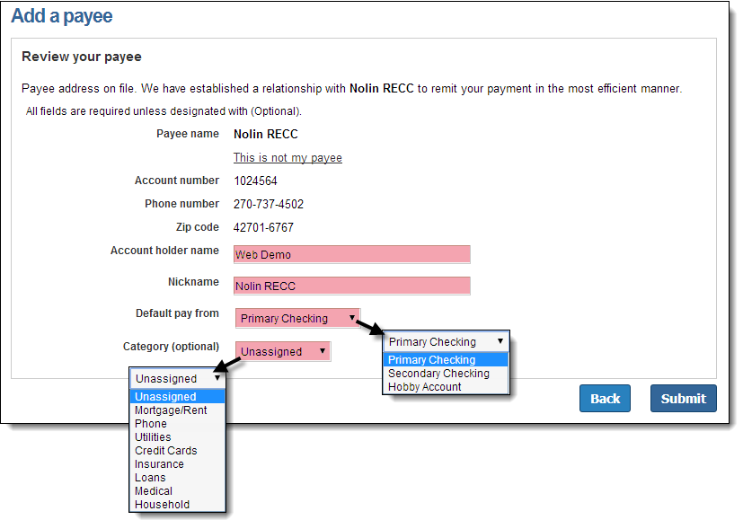

Newly added payees will be placed at the top of the payee list for the remainder of the bill pay session.

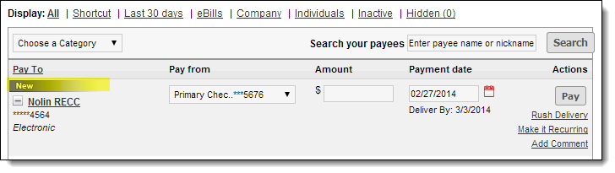

#### Pay an Individual

**Three options to add an individual**

* Allow them to provide their banking information
* I have their bank account information
* Mail a check

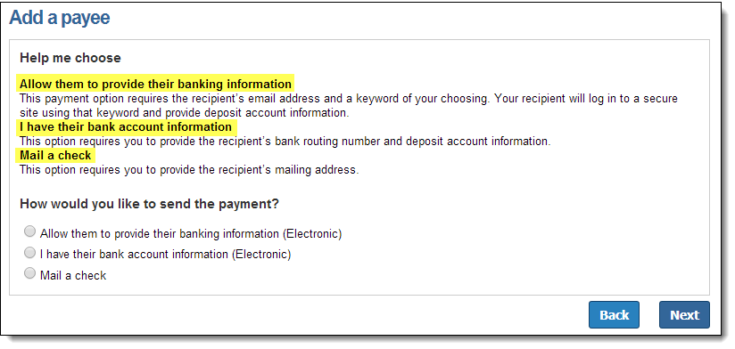

##### Allow them to provide their banking information (Electronic)

* User only needs the payee’s email address
* The payee will receive an email with a secure link that prompts them to submit their bank account information
* This is all passed behind the scenes so the user will never see it

**1st Step: Input the Payee’s information**: Name, Phone Number, and Email Address

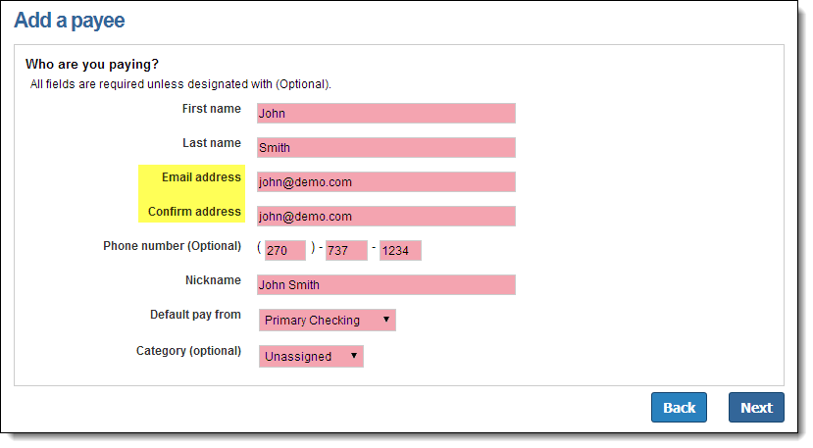

**2nd Step: Choose a Keyword**

**Keyword:** This can be any word that is communicated from the user to the payee. The payee will be required to enter this as a measure of security which will then prompt them to enter in their bank account information.

* The user can view the keyword when they edit the payee’s information.

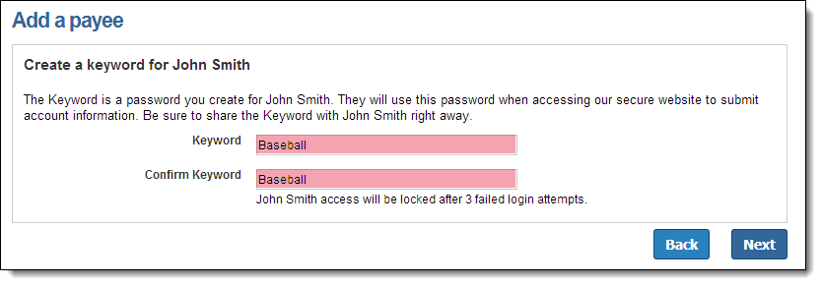

**3rd Step: Activate the Payee**

* Payee is activated by a one-time system generated code.
* Users can choose to activate payee now or later; however if they choose later, then they will be unable to schedule payment until the activation process is complete.

#### Activation Process

**Payee Activation:** Payee activation is an additional security feature for higher risk payees:

* Individual
* Bank or Credit Union

**Activation Code Details**

* One-time system generated code
* The activation code is specific to each and will expire if users:
  + Request a new code for the payee
  + Ends the bill pay session
* Users will be unable to select a specific delivery method if that piece of information has been changed in the site within the last 30 calendar days

**Activation Code Steps**

1. Select “**Preferred Delivery Method**” to receive the activation code: Phone, Email, or Text

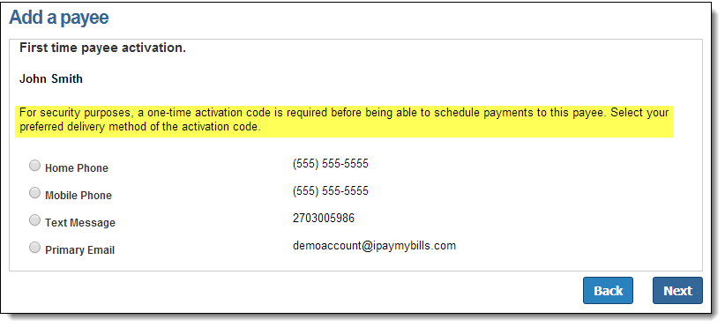

1. Enter Activation Code into field and then click “**Next**”

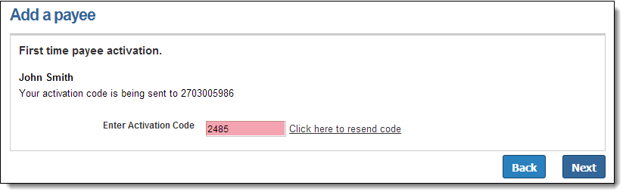

**4th Step:** Payee will be sent an email where they must enter:

* Key word
* Account Information
* Payments cannot be scheduled until the payee completes this process
* The payee has 9 days to enter their keyword and account information

** NOTE:** *The payee will have* ***9 days*** *to complete this process to become a permanent payee. If they fail to complete this, it will automatically delete them from the payee’s list and the user will be notified via email.*

##### Payee Locked Out

The payee can be locked out for entering the keyword incorrectly three times. After the first lockout, the system will automatically unlock the payee after 24 hours.

The user will have the ability to unlock them from:

* “**Attention Required**”
* By selecting the payees name from the landing page
* Contacting the support number

**To unlock the Payee via the Bill Pay site:**

**Option 1:** Select the unlock option beside the payee’s name under “**Attention Required**.”

 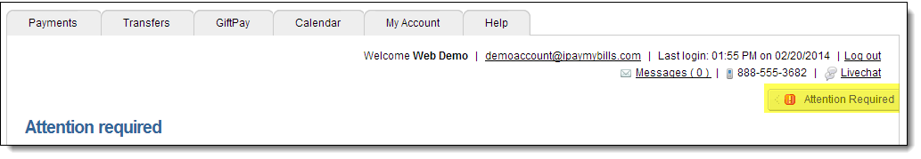

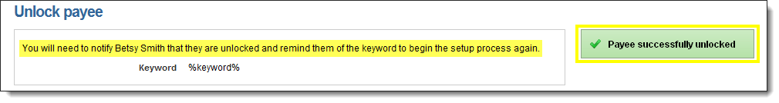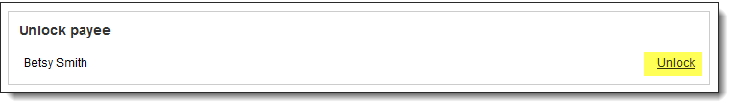

**Option 2:** Select the payee’s name from the landing page then select “**Unlock Payee**.”

 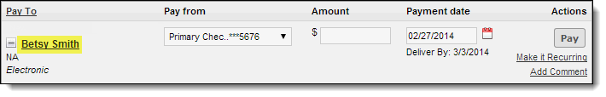

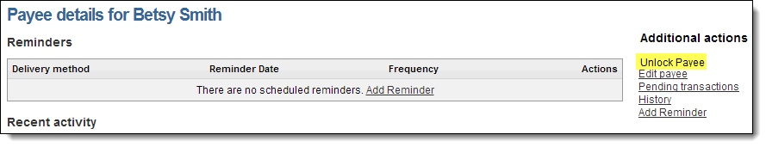





*\*After the third lockout (nine total failed attempts) the payee will be* ***deleted****.*

##### I have their bank account information (Electronic)

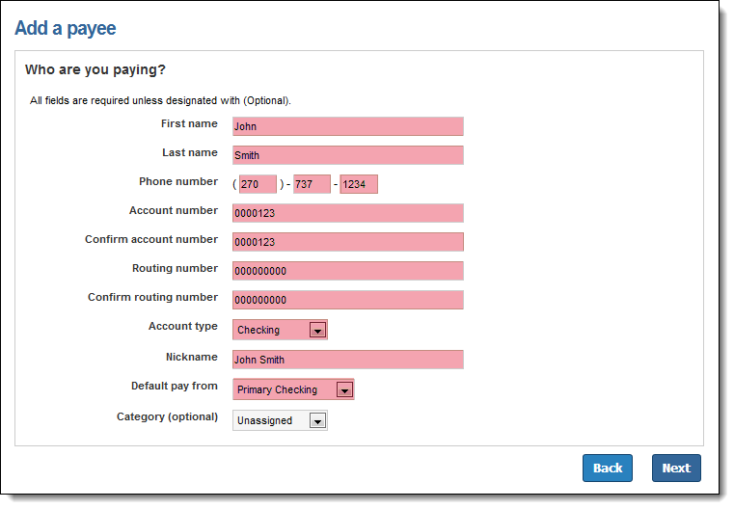

*\*Routing numbers will need to be valid routing numbers for the external institution.*

##### Mail a check

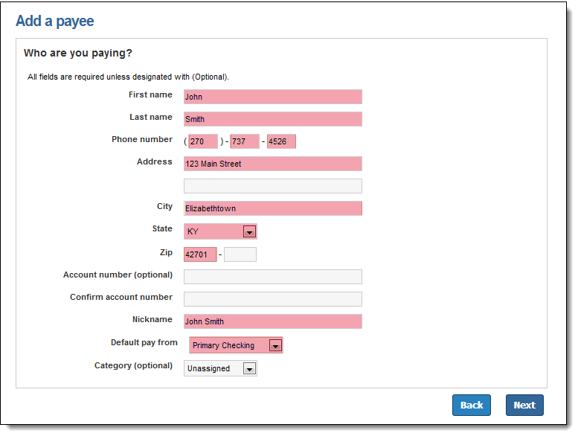

#### Pay a Bank or Credit Union

* **Types**: Loan, Credit Card, Checking, or Savings

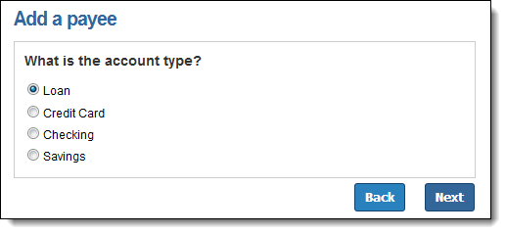

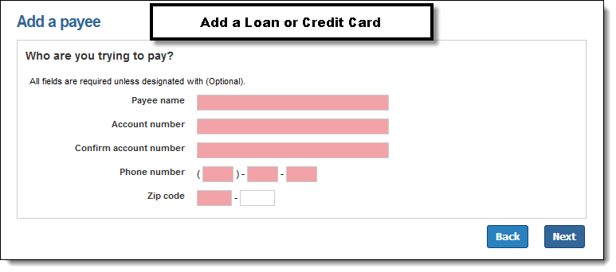

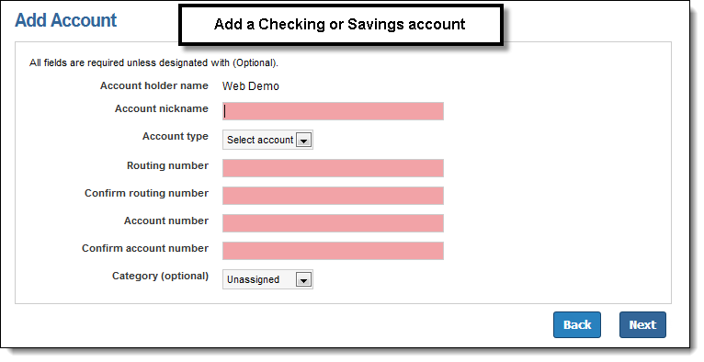

### Manage Payees

All payees are listed on the landing page.

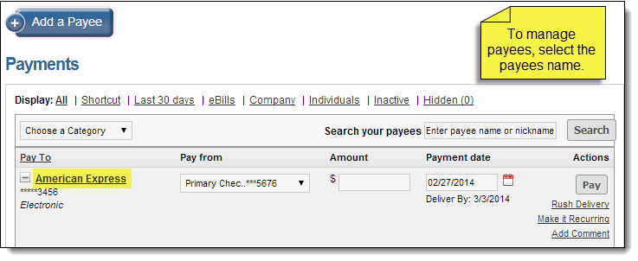

Users will have the following options to manage their payees:

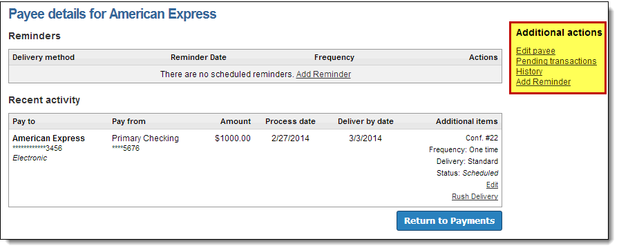

**Edit:** They can change the payee account information or “**Delete**” the payee.

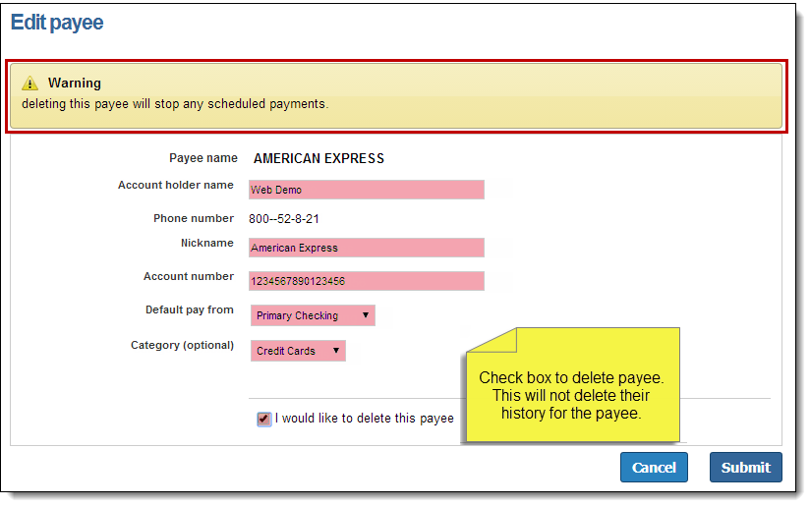

**Add Reminder:**

These are reminders to pay a bill.

 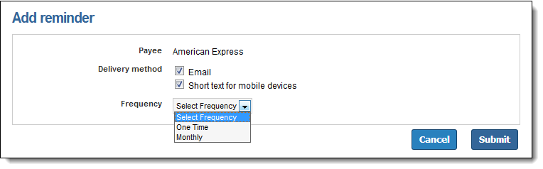

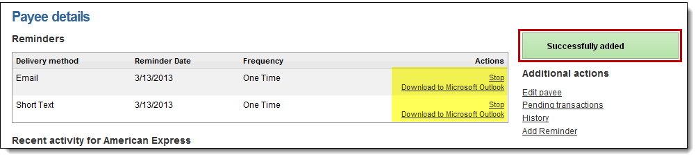

*\*Reminders can be downloaded into Microsoft Outlook*

#### Hide Payee

An icon to the left of each payee’s name on the Payment tab will allow users to “**Hide**” payees.

By hiding a payee, it will only be visible in the “**Hidden**” display option.

* Payees will remain **only** in this display option until the subscriber takes action to “**Show**” them.

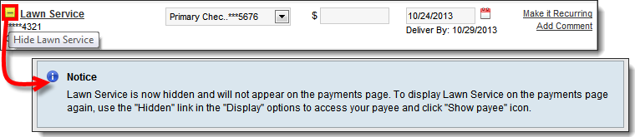

*Scheduled payments and reminders will not be affected by the payee being hidden.*

#### Show Hidden Payees

Under the “**Hidden**” display view, an icon will allow the users to “**Show**” a payee again.

* This will return the payee to all display views.

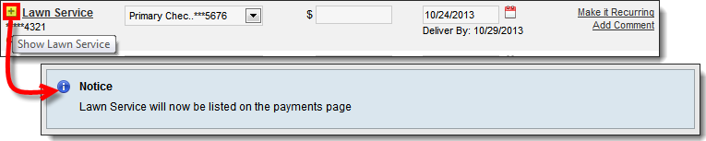

## Scheduling Payments

* Pay a Company
* Pay an Individual
* Pay a Bank or Credit Union

### One Time Payments

**Step 1:** Users will select a “**Pay From**” account, “**Amount**”, and the “**Payment Date**”

* The first available Payment Date will be prefilled.

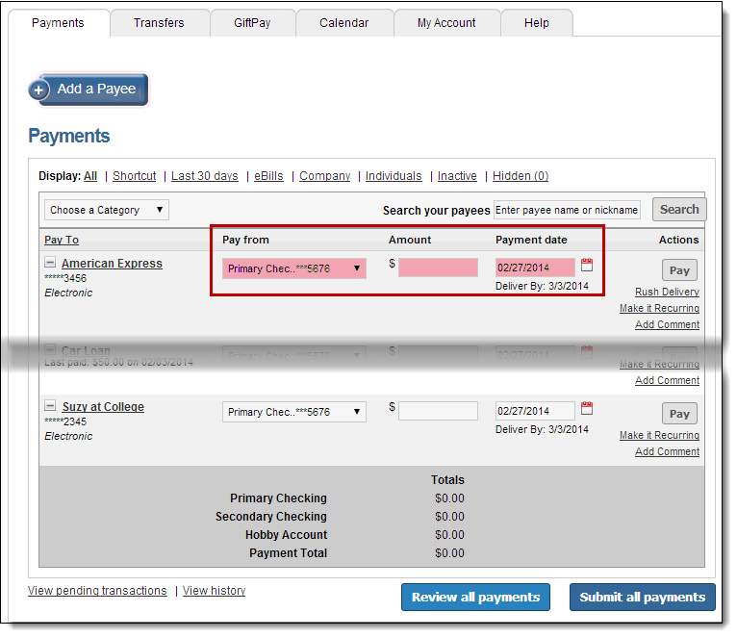

**Payment Date Calendar**

* Select payment date from calendar
* Payments only process Monday – Friday

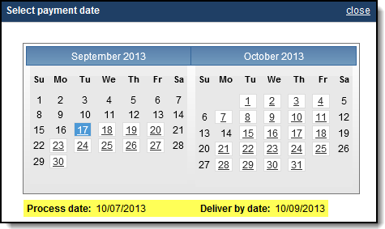

**Step 2**: Click **“Submit Payment”** to receive the Confirmation Number

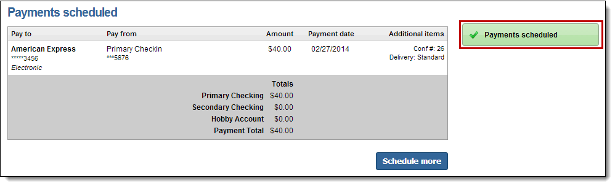

### Recurring Payments

These are payments that are paid on a recurring basis.

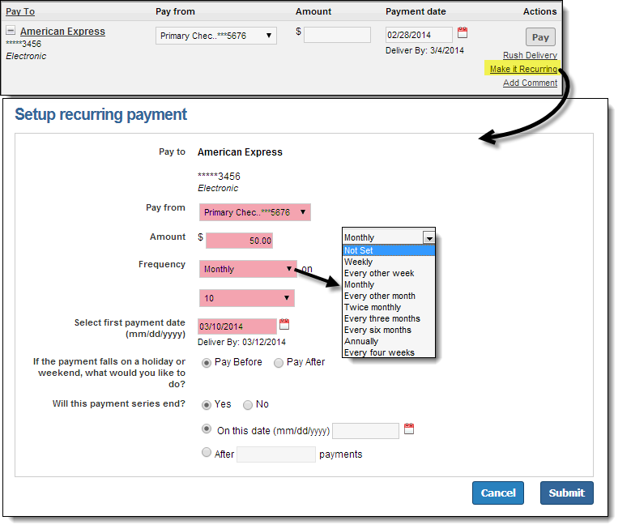

Users can receive an alert when there is one payment remaining in the series.

*\*See Alert section below.*

### View Pending Transactions

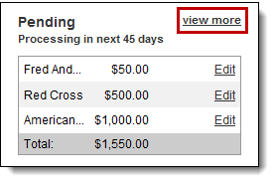

These payments are in a “**Scheduled**” status and have not processed therefore users have the option to “**Edit**” or “**Stop**.”

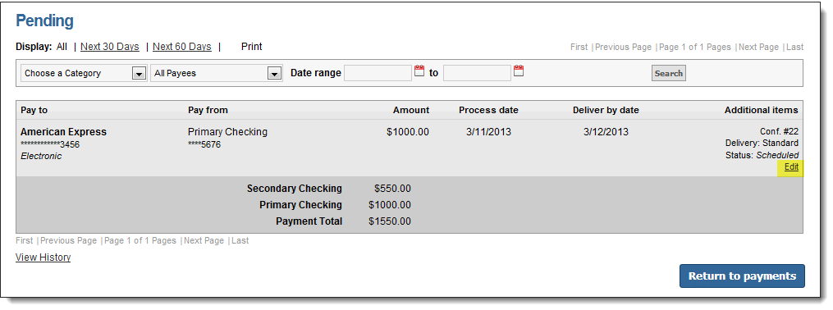

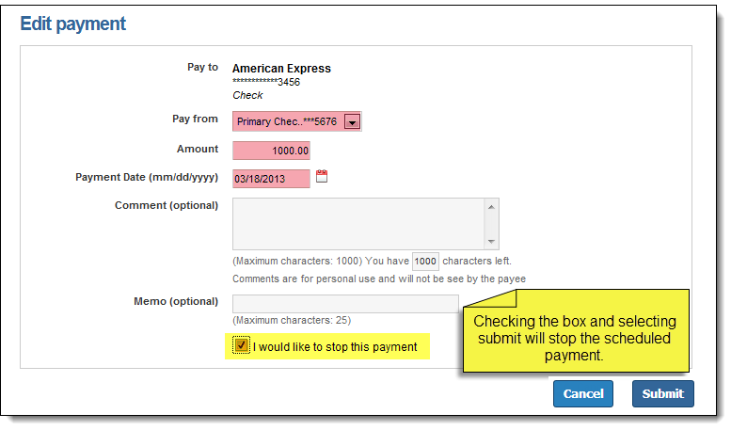

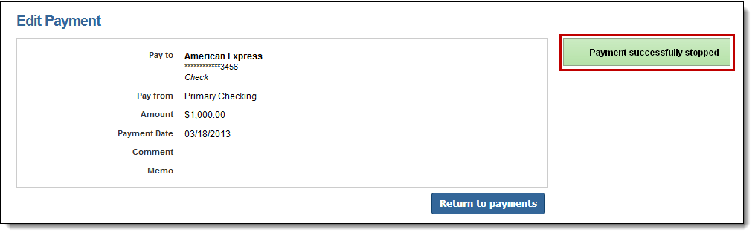

### View History

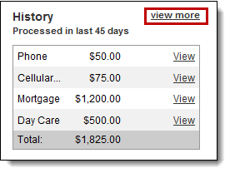

* These payments have processed and paid out
* **18 months** of payment history stored

Users have the option to “**View**” details.

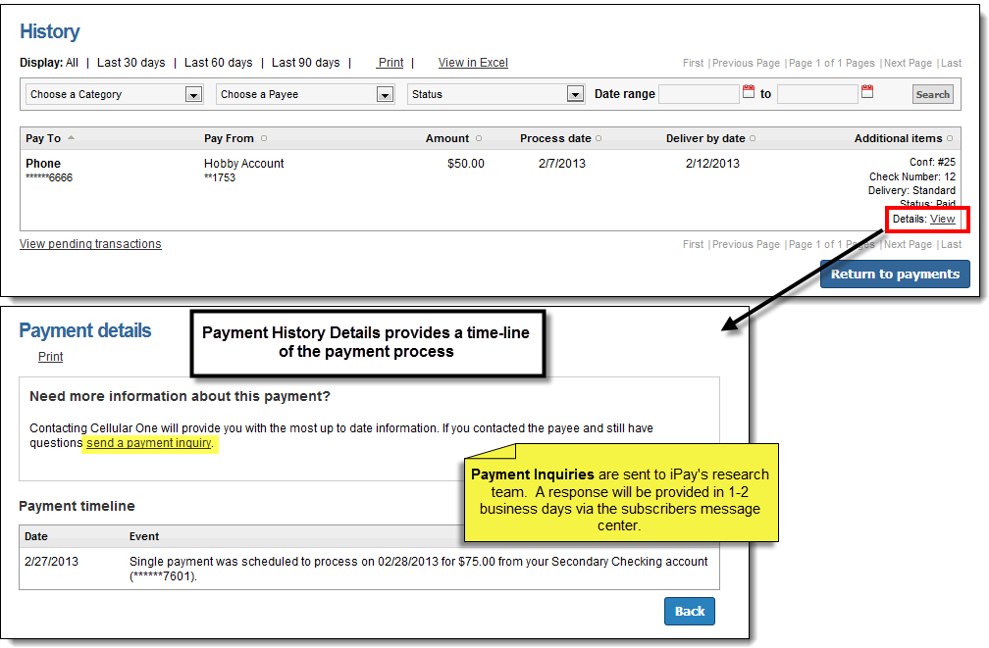

## Calendar

The calendar provides a “snap shot” view of the entire months bill payment activity.

* The calendar can be view in two display formats: **Month** and **List**.
* Both calendars are interactive and will allow users to access their Reminders, Pending Transactions, and Pending History.
  + The **Month** view will direct users to the details for the specific day.
  + The **List** view will direct users to the details for the specific transaction or reminder.
* Users can also view previous months as well as look ahead to upcoming months.

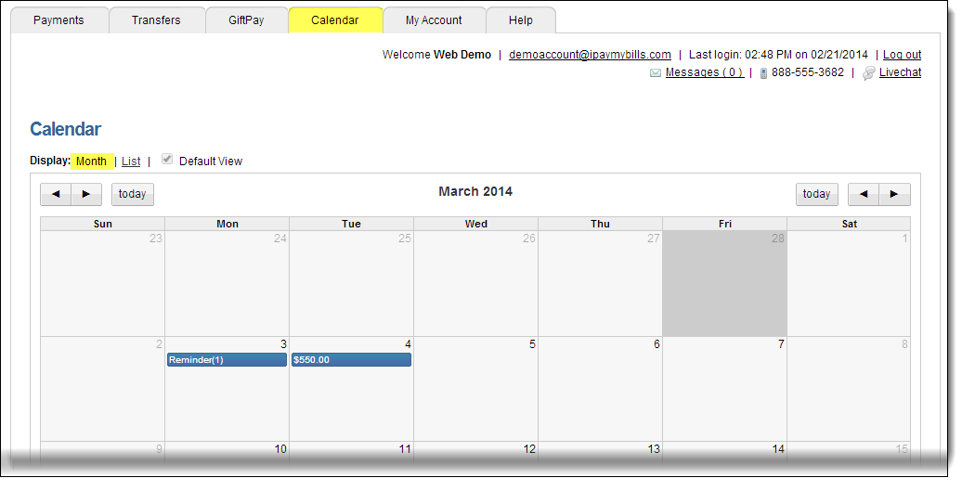

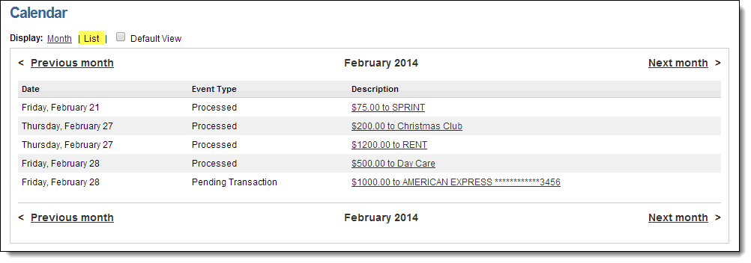

## My Account

There are several options available to assist the user in managing their bill pay account.

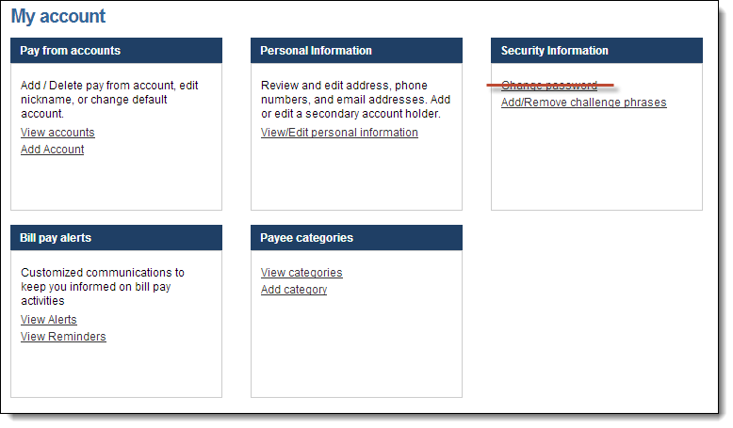

### Pay From Accounts

#### Add Accounts

This allows users to add additional “**Pay From Accounts**.”

* Each additional pay from account will require approval from the Institution.

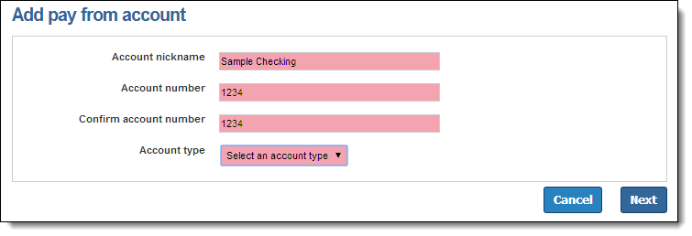

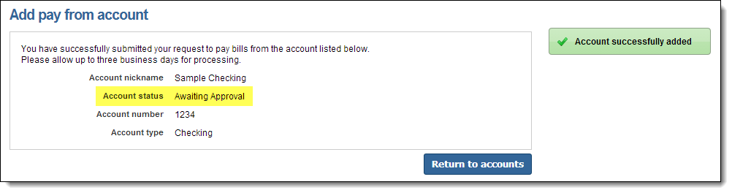

#### View Accounts

* View “**Pending**” and “**Approved**” accounts
* Options to change the **Nickname**, **Default** **Pay** From **Account**, and **Delete**



**Deleting a pay from account will stop all pending transactions associated with it.**

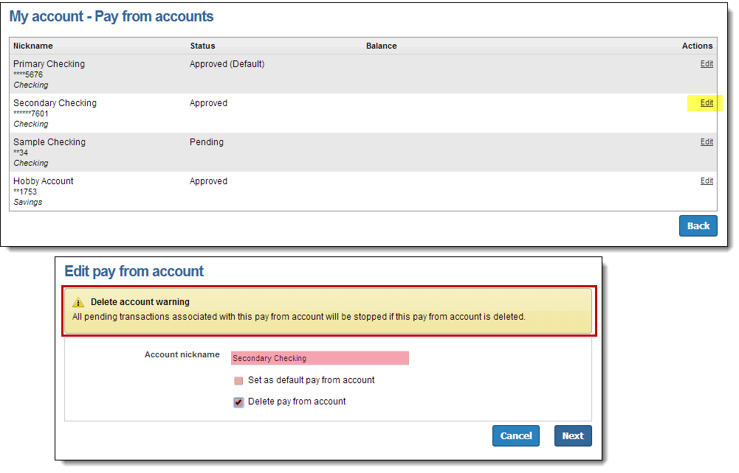

### Personal information

Users can update their contact information as well as add a Secondary User.

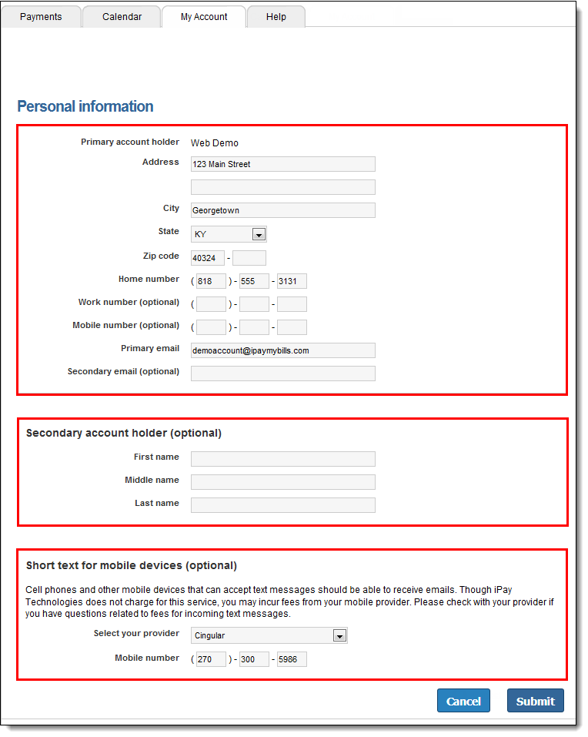

1. **Contact Information**: Users can update their primary contact information including their address, phone numbers, and email addresses.
2. **Secondary Account Holder**: The primary user can add a secondary user to the bill pay account.
   * Secondary Account Holders can only be added and viewed here.
   * **Secondary Users must be approved by the Institution.**
3. **Short Text for Mobile Devices**: This allows users to update their mobile number and carrier allowing them to receive text alerts from bill pay.

### Bill Pay Alerts

* Alerts allow users to monitor activity and assist with detecting fraud on their bill pay account.
* Alerts can be sent to email, text message, or both.
* Users can **view** and **stop** reminders.

#### View Alerts

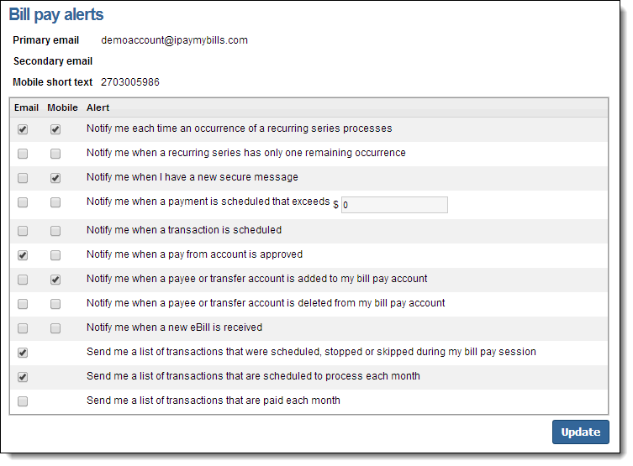

#### View Reminders

Users will have the option to stop the reminder or add it to their **Microsoft Outlook Calendar**.



**Reminders are added under the “Edit” payee option.**

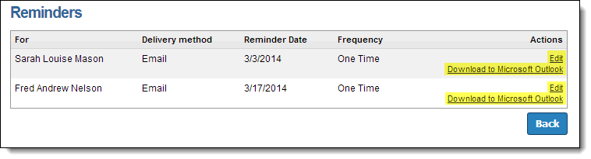

### Payee Categories

#### Add Categories

Users can manage multiple payees by creating personalized categories.



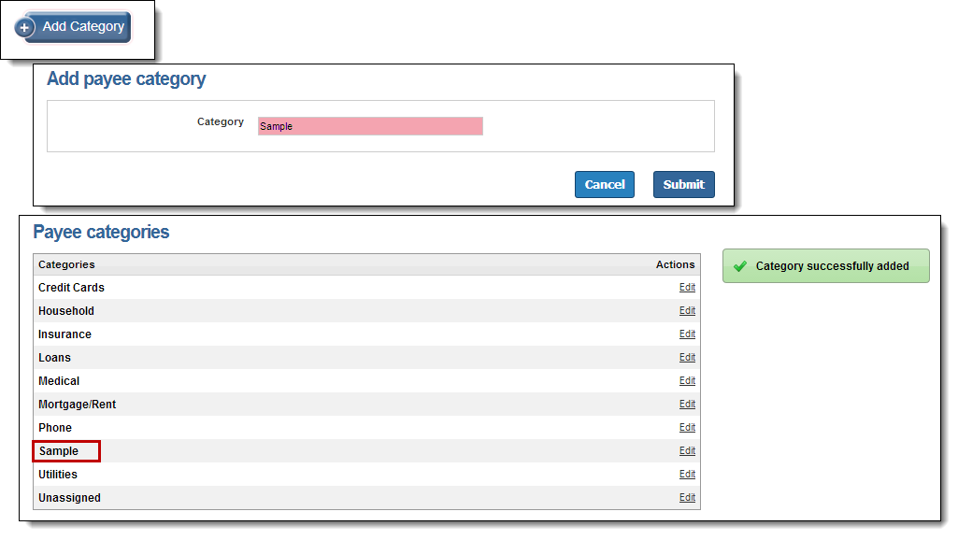

#### View Categories

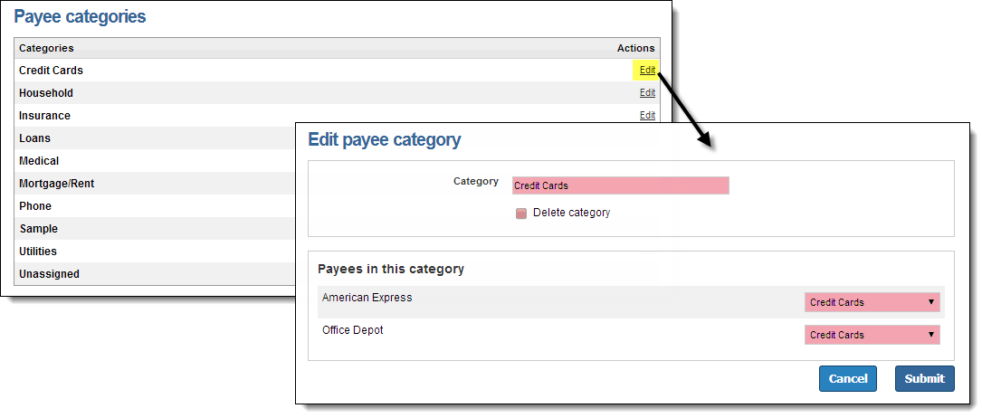

All payees who have not been assigned to a category will appear under “**Unassigned**.”

* To move these payees to a specific category from this section, simply select “**Edit**” then re-assign the Payee to a new category from the drop down list on the right.

## FAQ

### Help Tab

